Lecture-9

- Define Floorplanning problem. What is its objective?
- Define sliceable and non-sliceable floorplan with examples.
- What are the advantages of sliceable floorplan?
- State with an example how a sliceable floorplan can be represented by a binary tree.
- What is the hierarchical order of floorplan ?
- When an adjacency graph cannot admit a rectangular dual?
- What are the different types of internal nodes for a hierarchical floorplan.
- Obtain the hierarchical floorplan tree for the floorplan given in Fig.3.
- Illustrate the steps of rectangular dualization on an inherently non-sliceable graph of n vertices.
- Obtain a rectangular dual of the following adjacency graph.

Fig. 1
- Obtain the rectangular dual of the following adjacency graph below of Fig. 2.
- Prove that there is a one-to-one correspondence between a sliceable floorplan and a normalized Polish expression.
- Give the adjacency graph for the following floorplan of Fig.3.
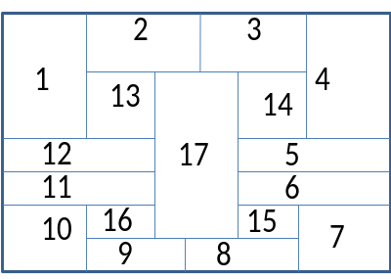
Fig. 2 Fig.3

Lecture-10

- Explain Bottom-up and Top-down approach in Floorplan.
- What is extended dual.
- Prove that if a rectangular dual graph does not contain any PTG, it can always have a corresponding sliceable floorplan.
- Show with the example that the number of possible sliceable floorplan increases exponentially with the number of modules.
- Explain Hierarchical floorplan with some Greedy procedure for a sliceable floorplan.
- State the steps in the Hierarchical floorplan with Bottom up Greedy procedure for the following adjacency graph, where edges have some weights.
- Explain how the procedure in question 36 may lead to wastage of space. What is the solution for it?
- How do you estimate the cost of floorplan.
- Consider the following adjacency graph where the edge weights are providing the distance between two vertices. Estimate the routing cost in different sliceable florplans for it.
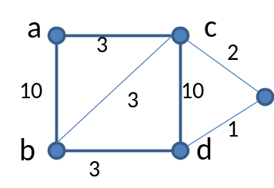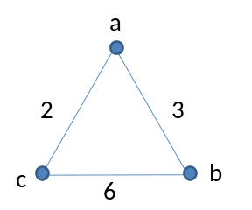
Fig.6 Fig.7

- What is simulated annealing? How simulated annealing approach can be applied in Floorplan.
- State the three different operations in simulated annealing approach in Floorplanning. How they will be applied in a given floorplan.
- Given a Polish expression corresponding to a given slicing floorplan. Show that the expression 12+3+4+…….+n+ can be reached, and vice versa, using three operations in simulated annealing approach of floorplan. (+ and * represent horizontal and vertical bisection respectively.)
- State Floorplan sizing problem.
- Considering hierarchical nature of floorplan, discuss how to deal with the sizing problem.
- In a hierarchical florrplan sizing problem, there are given two subfloorplans corresponding to two subtrees of a node v, one with t and other with s nonredundant implementations, prove that v has at most s+t-1 nonredundant realizations.
- Given a fllorplan with fixed cell environment, what are the significance of horizontal dependency graph and vertical dependency graph.
- Draw the horizontal and vertical dependency graph of the floorplan given in Fig. 3.
- Considering no restriction on the organization of the modules, formulate the floorplan sizing problem as an Integer Linear Programming (ILP).
- What are the advantages of integer linear programming technique in case in floorplanning.

Lecture-11

- What is placement problem in VLSI physical design?
- State the consequences of placement in VLSI Design.
- State the importance of Placement problem.
- What are constrained and un-constrained placement?
- What may be the different constraints in placement problem?
- Give a brief discussion on the objective functions and routing estimation in placement.
- Formulate the placement problem.
- Discuss the cost components in Placement.
- What are global and detailed placement?
- State the various approaches for placement problem- Top-down, iterative, constructive?
- What are the different types of placement algorithms?
- Explain the Force directed Placement algorithm. Explain its similarity with force calculation in a spring.
- Explain constructive force directed placement technique.
- Explain iterative force directed technique. What are its two approaches?
- Compare the constructive and iterative algorithm in Placement problem.
- What are pros and cons of Force directed algorithm?

Lecture-12

- Explain congestion problem in time of placement.
- State partitioning technique in placement approach with goal and objectives.
- Explain the partitioning based algorithm – its goal and objectives?
- Explain the different procedures for Breuer’s Algorithm.
- What are pros and cons of Breuer’s algorithm?
- Explain simulated annealing algorithm in case of placement problem. What are its different issues? What may be the different moves of the modules in this approach? What may be the cost function? How the range of movement may change with time?
- What are the pros and cons of simulated annealing approach?
- What is analytical placement? What is the advantage of doing this type of placement?
- Explain the quadratic placement approach.
- State the pros and cons of quadratic placement approach.
- State the clustering approach in case of placement.

